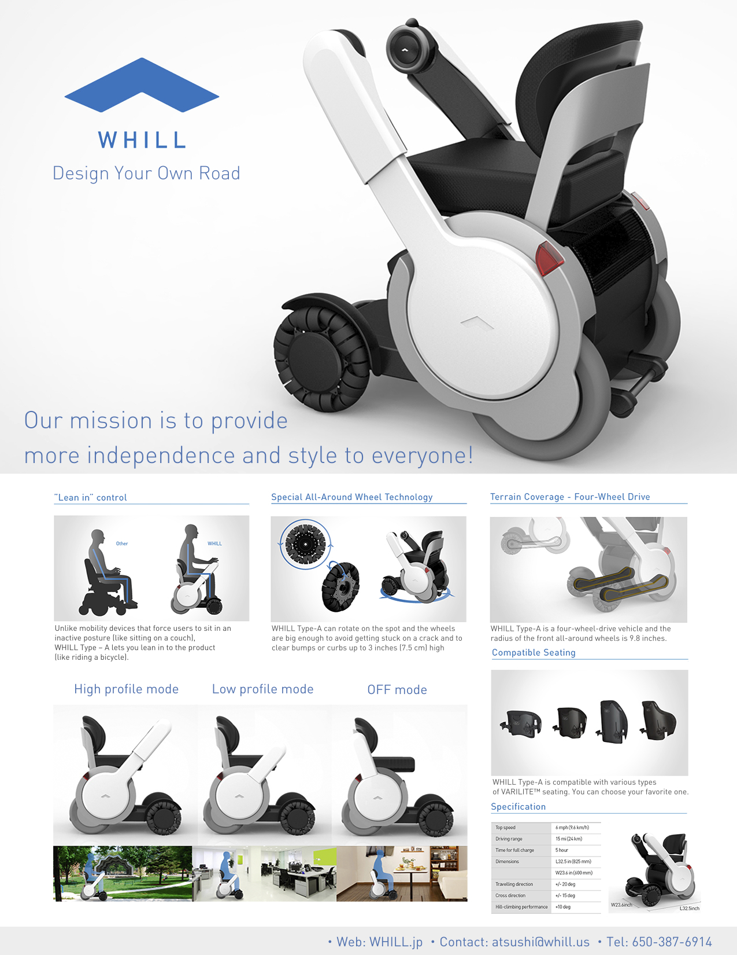

ILRCSF is wheelchair accessible and provides reasonable accommodations upon advanced request. In order to be fully accessible to all people with disabilities, ours is a scent-free office When visiting ILRCSF, please do not wear any scented products, including perfumes, aftershave, hairspray, etc."

For reasonable accommodations or to **RSVP** for this event, **please contact Peter Mendoza at** [**415-543-6222 x106**](tel:415-543-6222%20x106) **or by email at** [**peter@ilrcsf.org**](mailto:peter@ilrcsf.org)

**Thu Dec 5, 2013 11:00pm-12:30pm**

**@Independent Living Resource Center San Francisco**

(649 Mission St., 3rd Floor San Francisco, CA)

**Come**

**Try & Feel**

**WHILL Type-A!**

Be the one to experience Type-A first in the world!