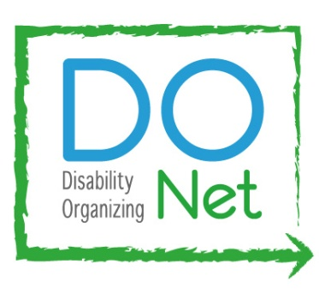
SAVE THE DATE & JOIN US!

ACCESS NOW Community Living Campaign
BART Strike Disability Rally
And
Press Conference

Who: People with disabilities and their allies who use BART to travel for work, health care, school, shopping and living full lives

What: Join us to educate BART management and workers and Bay Area everyday citizens about the impact of the BART Strike on people with disabilities and our allies.

When: Wednesday October 16, 2013 at 10:30 am
Please plan to arrive at 9:30 am for lining up and pre-rally organizing

Where: TransBay Temporary Terminal
Howard and Main Street in downtown San Francisco
For alternate transportation information during the BART Strike please visit http://temporaryterminal.org/ or call 511.

RSVP: Click on this link or paste it in your browser to take the RSVP survey: http://www.surveymonkey.com/s/C7ZPMFB
Please make sure to give us your email address on the RSVP survey so that we can send you confirmation, transportation and poster slogan information.

